**Ideation Phase**

**Define the Problem Statements**

|  |  |
| --- | --- |
| Date | 26 june 2025 |
| Team ID | single |
| Project Name | Freelance application mern |
| Maximum Marks | 2 Marks |

**Customer Problem Statement Template:**

To define the core problems freelancers face while searching for jobs online, and use those

insights to guide the development of Freelanced .

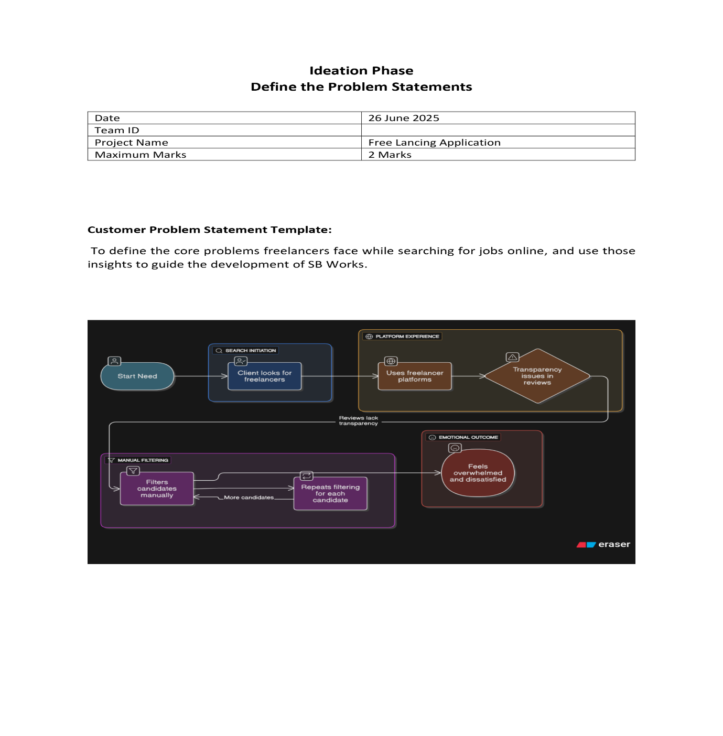

Customer Problem Statements

For Freelancers:

| **Problem Statement** | **I am...** | **I'm trying to...** | **But...** | **Because...** | **Which makes me feel...** |
| --- | --- | --- | --- | --- | --- |
| PS-1 | A skilled freelancer (developer/designer) | find quality projects that match my expertise | most platforms prioritize low-cost bids over quality | the algorithms favor cheaper options rather than skills | undervalued and frustrated |
| PS-2 | A creative professional | build lasting client relationships | platforms treat projects as one-time transactions | there's no project continuity features | like a commodity rather than a professional |
| PS-3 | A new freelancer | establish my reputation | need completed projects to get ratings | can't get projects without existing ratings | stuck in a catch-22 situation |

For Clients:

| **Problem Statement** | **I am...** | **I'm trying to...** | **But...** | **Because...** | **Which makes me feel...** |
| --- | --- | --- | --- | --- | --- |
| PS-4 | A startup founder | find reliable tech talent | struggle to assess true skills from profiles | portfolios don't show actual problem-solving ability | uncertain and anxious |
| PS-5 | A project manager | manage collaborative projects | current platforms lack integrated tools | need to use 5+ different apps | overwhelmed and inefficient |
| PS-6 | A creative director | find specialized talent | generic platforms don't filter niche skills | search results show irrelevant candidates | frustrated with wasted time |

Our Solution Highlights

* **Smart Matching Algorithm**: Connects skills to projects, not just budgets
* **Portfolio Builder**: With interactive project showcases (not just PDFs)
* **Collaboration Hub**: Built-in whiteboard and version control
* **Reputation Bridge**: Apprenticeship program for new freelancers
* **Talent Verification**: Live skill testing integrated in hiring flow

These pain points directly inform our platform's:

1. Bid-free project matching system
2. Interactive portfolio tools
3. Built-in collaboration workspace
4. Tiered reputation system
5. Verified skill badges